SWT 22022 – Practical for Internet Application Development
Department of Information and Communication Technology
Faculty of Technology
Lab sheet :07
Reg. Number: SEU/IS/20/ICT/084
Academic Year :2020/2021
Date: 2024.07.03
Practical No :07

Title: Getting and Passing Data from HTML to PHP Using Ajax.
Aims:
• To understand the concept of Ajax and its benefits.
• To learn how to make Ajax request with JQuery.
• To learn how to process Ajax request in PHP
Tasks:
• Import JQuery
• Implement AJAX request with JQuery
• Perform text field validation
• Process data in PHP

Activities :
- Import JQuery
<scriptsrc="https://ajax.googleapis.com/ajax/libs/jquery/3.7.1/jquery.min.js"></script>

2. Implement AJAX request with JQuery
I. POST request

$.ajax({
url: "add_student.php",
type: "POST",
data: {
name: name,
gpa: gpa
},
success: function(response) {
try {
var data = JSON.parse(response);
if (data.success) {
$("#studentForm").trigger("reset");
console.log("Student added successfully!");
if (data.students) {
$("#studentTable tbody").empty();
for (var i = 0; i <data.students.length; i++) {
var student =data.students[i];
var tableRow = "<tr>";
tableRow += "<td>" +student.id + "</td>";
tableRow += "<td>" +student.name + "</td>";
tableRow += "<td>" +student.gpa + "</td>";
tableRow += "</tr>";
$("#studentTable tbody").append(tableRow);
}
}
} else {
alert("Error adding student: " +data.message);
}
} catch (error) {
console.error("Error parsing response:", error);
alert("An error occurred while adding student. Please check your server logs.");
}
},
error: function (jqXHR, textStatus,errorThrown) {
console.error("AJAX Error:", textStatus,errorThrown);
alert("An error occurred while adding student.");
}
});

II. GET request

$.ajax({
url: "get_students.php",
type: "GET",
success: function(response) {
try {
var data = JSON.parse(response);
if (data.success && data.students && Array.isArray(data.students)) {
$("#studentTable tbody").empty();
for (var i = 0; i < data.students.length;i++) {
var student = data.students[i];
var tableRow = "<tr>";
tableRow += "<td>" + student.id +"</td>";
tableRow += "<td>" + student.name +"</td>";
tableRow += "<td>" + student.gpa +"</td>";
tableRow += "</tr>";
$("#studentTable tbody").append(tableRow);
}
} else {
console.warn("Unexpected response format:students array not found.");
}
} catch (error) {
console.error("Error parsing response:",error);
alert("An error occurred while retrieving student data.");
}
},
error: function(jqXHR, textStatus, errorThrown) {
console.error("AJAX Error:", textStatus,errorThrown);
alert("An error occurred while retrieving student data.");
}
});

- Perform text field validation
var name = $("#name").val();
var gpa = parseFloat($("#gpa").val());
if (name.trim() === "") {
alert("Please enter a name.");
return;
}
if (isNaN(gpa) || gpa < 0 || gpa > 4) {
alert("Please enter a valid GPA between 0 and 4.");
return;
}
4. Process data in PHP
I. get_stidents.php

if ($_SERVER['REQUEST_METHOD'] === 'GET') {
include ('DatabaseConnection.php');
include ('Student.php');
$db = new DatabaseConnection("localhost", "root", "","faculty");
$connection = $db->getConnection();
$student = new Student($connection);
$studentData = $student->getAllStudent();
$response = array();
if ($studentData) {
$response['success'] = true;
$response['students'] = $studentData;
} else {
$response['success'] = false;
$response['message'] = "Error creating student";
}
echo json_encode($response);
} else {
echo "Invalid request.";
}

II. add_students.php

if ($_SERVER['REQUEST_METHOD'] === 'POST') {
$name = $_POST['name'];
$gpa = floatval($_POST['gpa']);
include ('DatabaseConnection.php');
include ('Student.php');
$db = new DatabaseConnection("localhost", "root", "","faculty");
$connection = $db->getConnection();
$student = new Student($connection);
$student->setName($name);
$response = array();
if ($result) {
$response['success'] = true;
$studentData = $student->getAllStudent();
$response['students'] = $studentData;
} else {
$response['success'] = false;
$response['message'] = "Error creating student";
}
echo json_encode($response);
} else {
echo "Invalid request.";
}

Index.php
<!DOCTYPE html>
<html lang="en">
<head>
<meta charset="UTF-8">
<meta name="viewport" content="width=device-width, initial-scale=1.0">
<title>Students</title>
<script src="https://ajax.googleapis.com/ajax/libs/jquery/3.7.1/jquery.min.js"></script>
<link href="https://cdn.jsdelivr.net/npm/bootstrap@5.3.3/dist/css/bootstrap.min.css" rel="stylesheet" integrity="sha384-QWTKZyjpPEjISv5WaRU9OFeRpok6YctnYmDr5pNlyT2bRjXh0JMhjY6hW+ALEwIH" crossorigin="anonymous">
<script src="https://cdn.jsdelivr.net/npm/bootstrap@5.3.3/dist/js/bootstrap.bundle.min.js" integrity="sha384-YvpcrYf0tY3lHB60NNkmXc5s9fDVZLESaAA55NDzOxhy9GkcIdslK1eN7N6jIeHz" crossorigin="anonymous"></script>
</head>
<body class="bg-light">

<div class="container mt-5">
<h1 class="mb-4">Student Management</h1>

<form id="studentForm" class="mb-4">
<div class="mb-3">
<label for="name" class="form-label">Student Name</label>
<input type="text" id="name" class="form-control" placeholder="Student Name" required>
</div>
<div class="mb-3">
<label for="gpa" class="form-label">GPA</label>
<input type="number" id="gpa" class="form-control" placeholder="GPA" required step="0.01" min="0" max="4.0">
</div>
<input type="submit" value="Add Student" class="btn btn-primary">
</form>

<table id="studentTable" class="table table-striped">
<thead>
<tr>
<th>ID</th>
<th>Name</th>
<th>GPA</th>
</tr>
</thead>
<tbody>
</tbody>
</table>
</div>

<script>
$(document).ready(function() {
loadStudents();

// Prevent default form submission
$("#studentForm").on("submit", function(event) {
event.preventDefault(); // Prevent the form from submitting the traditional way
addStudent(); // Call the function to add a student
});
});

function loadStudents() {
$.ajax({
url: "get_students.php",
type: "GET",
success: function(response) {
try {
var data = JSON.parse(response);
if (data.success && data.students && Array.isArray(data.students)) {
$("#studentTable tbody").empty();
for (var i = 0; i < data.students.length; i++) {
var student = data.students[i];
var tableRow = "<tr>";
tableRow += "<td>" + student.Id + "</td>";
tableRow += "<td>" + student.Name + "</td>";
tableRow += "<td>" + student.Gpa + "</td>";
tableRow += "</tr>";
$("#studentTable tbody").append(tableRow);
}
} else {
console.warn("Unexpected response format: students array not found.");
}
} catch (error) {
console.error("Error parsing response:", error);
alert("An error occurred while retrieving student data.");
}
},
error: function(jqXHR, textStatus, errorThrown) {
console.error("AJAX Error:", textStatus, errorThrown);
alert("An error occurred while retrieving student data.");
}
});
}

function addStudent() {
var name = $("#name").val().trim();
var gpa = parseFloat($("#gpa").val());

if (name === "") {
alert("Please enter a name.");
return;
}
if (isNaN(gpa) || gpa < 0 || gpa > 4) {
alert("Please enter a valid GPA between 0 and 4.");
return;
}

$.ajax({
url: "add_student.php",
type: "POST",
data: {
name: name,
gpa: gpa
},
success: function(response) {
try {
var data = JSON.parse(response);
if (data.success) {
$("#studentForm").trigger("reset");
loadStudents(); // Reload the student list
console.log("Student added successfully!");
} else {
alert("Error adding student: " + data.message);
}
} catch (error) {
console.error("Error parsing response:", error);
alert("An error occurred while adding the student. Please check your server logs.");
}
},
error: function(jqXHR, textStatus, errorThrown) {
console.error("AJAX Error:", textStatus, errorThrown);
alert("An error occurred while adding the student.");
}
});
}
</script>
</body>
</html>

Student.php
<?php
class Student {
private $name;
private $gpa;
private $id;
private $connection;

public function __construct($connection) {
$this->connection = $connection;
}

public function setName($name) {
$this->name = mysqli_real_escape_string($this->connection, $name);
}

public function setGpa($gpa) {
$this->gpa = $gpa;
}

public function create() {
if (empty($this->name) || empty($this->gpa)) {
return false;
}
$query = "INSERT INTO student (Name, Gpa) VALUES (?, ?)";
$stmt = mysqli_prepare($this->connection, $query);
mysqli_stmt_bind_param($stmt, 'sd', $this->name, $this->gpa);

return mysqli_stmt_execute($stmt);
}

public function getAllStudents() {
$query = "SELECT * FROM student";
$result = mysqli_query($this->connection, $query);
if (!$result) {
return [];
}
$students = [];
while ($row = mysqli_fetch_assoc($result)) {
$students[] = $row;
}
return $students;
}
}

?>
DatabaseConnection.php
<?php
class DatabaseConnection {
private $host;
private $username;
private $password;
private $database;
private $connection;

public function __construct($host, $username, $password, $database) {
$this->host = $host;
$this->username = $username;
$this->password = $password;
$this->database = $database;

$this->connect();
}

private function connect() {
$this->connection = mysqli_connect($this->host, $this->username, $this->password, $this->database);
if (!$this->connection) {
die("Database connection failed: " . mysqli_connect_error());
}
}

public function getConnection() {
return $this->connection;
}
}

?>

get_students.php
<?php
if ($_SERVER['REQUEST_METHOD'] === 'GET') {
include ('DatabaseConnection.php');
include ('Student.php');
$db = new DatabaseConnection("localhost", "root", "","faculty");
$connection = $db->getConnection();
$student = new Student($connection);
$studentData = $student->getAllStudents();
$response = array();
if ($studentData) {
$response['success'] = true;
$response['students'] = $studentData;
} else {
$response['success'] = false;
$response['message'] = "Error creating student";
}
echo json_encode($response);
} else {
echo "Invalid request.";
}

add_student.php

<?php
if ($_SERVER['REQUEST_METHOD'] === 'POST') {

$name = trim($_POST['name']);
$gpa = floatval($_POST['gpa']);

if (empty($name) || $gpa < 0 || $gpa > 4) {
echo json_encode([
'success' => false,
'message' => 'Invalid input data. Please check the name and GPA.'
]);
exit();
}

include ('DatabaseConnection.php');
include ('Student.php');

$db = new DatabaseConnection("localhost", "root", "", "faculty");
$connection = $db->getConnection();

$student = new Student($connection);
$student->setName($name);
$student->setGpa($gpa);

$result = $student->create();

$response = array();
if ($result) {
$response['success'] = true;
$studentData = $student->getAllStudents();
$response['students'] = $studentData;
} else {
$response['success'] = false;
$response['message'] = "Error creating student";
}

echo json_encode($response);
} else {
echo json_encode(['success' => false, 'message' => 'Invalid request.']);
}
?>

Output:
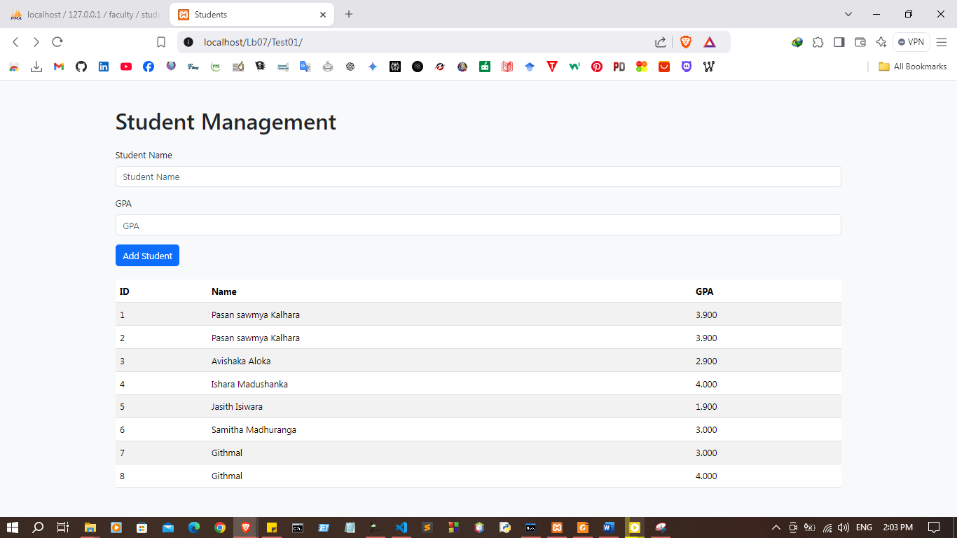

Discussion:
- In this lab session, we aimed to gain a deeper understanding of how to transfer data between the client-side (HTML) and server-side (PHP) using AJAX. We began by learning the core benefits of AJAX, such as its ability to update web content asynchronously without requiring a full page reload. Using jQuery, we implemented AJAX requests, which simplified the process of sending and receiving data from the server. Additionally, we focused on validating text fields dynamically on the client side, ensuring that user inputs met specific criteria before sending the data. On the server-side, we processed the submitted data using PHP, demonstrating how AJAX facilitates seamless communication between the front-end and back-end, leading to faster interactions and a smoother user experience. This integration of jQuery and PHP through AJAX highlighted how modern web applications can achieve real-time validation and data processing.

